

***Project report on***

***Hit and Die Action Game Development.***

Submitted to

Amity University, Ranchi (Jharkhand)



***In partial fulfilment of the requirements for the award of the degree of***

***Bachelor of Computer Applications***

By

**Umar Khosnood Rasheedi**

**A35404819040**

*Under the guidance of* ***Ms. Shalini Mahato***

**AMITY INSTITUTE OF INFORMATAION TECHNOLOGY, RANCHI**

**AMITY UNIVERSITY, RANCHI (JHARKHAND)**

**OCTOBER, 2020**

***DECLARATION***

I, **Umar Khosnood Rasheedi**, student of **Bachelor of Computer Applications** hereby declare that the Project titled **“ Hit and Die Action Game Development”** which is submitted by me to Computer Science and Information Technology Department, Amity Institute of Information Technology, Amity University, Ranchi (Jharkhand), in partial fulfillment of requirement for the award of degree of Bachelor of Computer Applications, has not been previously formed the basis for the award of any degree, diploma or other similar title or recognition. I further declare that report is written by me and no part of the report is copied from any source(s) without being duly acknowledged. If it is found to be plagiarized beyond acceptable limit, I owe the responsibility and action can be taken against me as per University Rules & Regulations.

Amity University, Ranchi (Jharkhand)

Date:

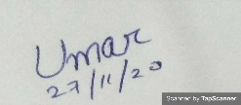

Sign. of the Student

Name of Student: Umar Khosnood Rasheedi

Enrollment Number: A35404819040

Semester: 3rd

Batch:2019-2022

**CERTIFICATE**

On the basis of Project Report submitted by **Umar Khosnood Rasheedi**, student of **Bachelor of Computer Applications**, I hereby certify that the Project Report on **“ Hit and Die Action Game Development”** which is submitted to Computer Science and Information Technology Department, Amity Institute of Information Technology, Amity University, Ranchi (Jharkhand) in partial fulfillment of requirement for the award of the degree of Bachelor of Computer Application is an original contribution with existing knowledge and faithful record of work carried out by him/her under my guidance and supervision.

To the best of my knowledge this work has not been submitted in part or full for any Degree or Diploma to this University or elsewhere.

Amity University, Ranchi (Jharkhand)

Date:

Signature of Guide (Internal)

Ms. Shalini Mahato

Assistant Professor

Amity Institute of Information Technology, Ranchi

Amity University, Ranchi (Jharkhand)

***ACKNOWLEDGEMENT***

*I would like to express a deep sense of thanks & gratitude to my my project guide by* ***Ms Shalini Mahato*** *for guiding me immensely through the course of project. She always evinced interest in my work. His constructive advice & constant motivation have been responsible for the successful completion of the project.*

*I always thanks to my parents for their motivation & support I must thanks to my classmates for their timely help and support for the completion of this project.*

*Yours Sincerely*

*Name of the Student: Umar Khosnood Rasheedi*

*Enrollment Number: A35404819040*

*Semester:3rd*

*Batch:2019-2022*

**Synopsis**

1) **Project Duration** : **(31 Days)**

a) Date of Summer Internship commencement **(28/09/2020)**

a) Date of Summer Internship Completion **(30/10/2020)**

2) **Topic**

Hit and Die Action Game Development using Java Script, HTML and CSS.

3) **Project Objective**

The main objective of this project is to develop action game Hit and Die.

4) **Methodology to be adopted**

a. Requirement Analysis b. Design c. Build d. Test e. Release and Maintain.

5) **Brief Summery of project(to be duly certified by the industry guide)**

In this project, basically a web-based game development where the main character is a dino who is standing at his place and the obstacle is continuously moving toward the character. To avoid the collision between the main character and the obstacle, the player (main character-the dino) must jump at the correct moment. In this this game there would be one default key( an arrow or an enter key). By pressing that key, the individual can safe the main character from collision with the obstacles by jumping across the obstacle. In this game the obstacle will be a Dinosaur and the main character is a dino. In each successful jump the score will increase by 1. This game increases the level concentration of an individual. The concepts used for the development of the game are HTML, CSS(Cascading Style Sheet) and Javascript.

**WPR Chart**

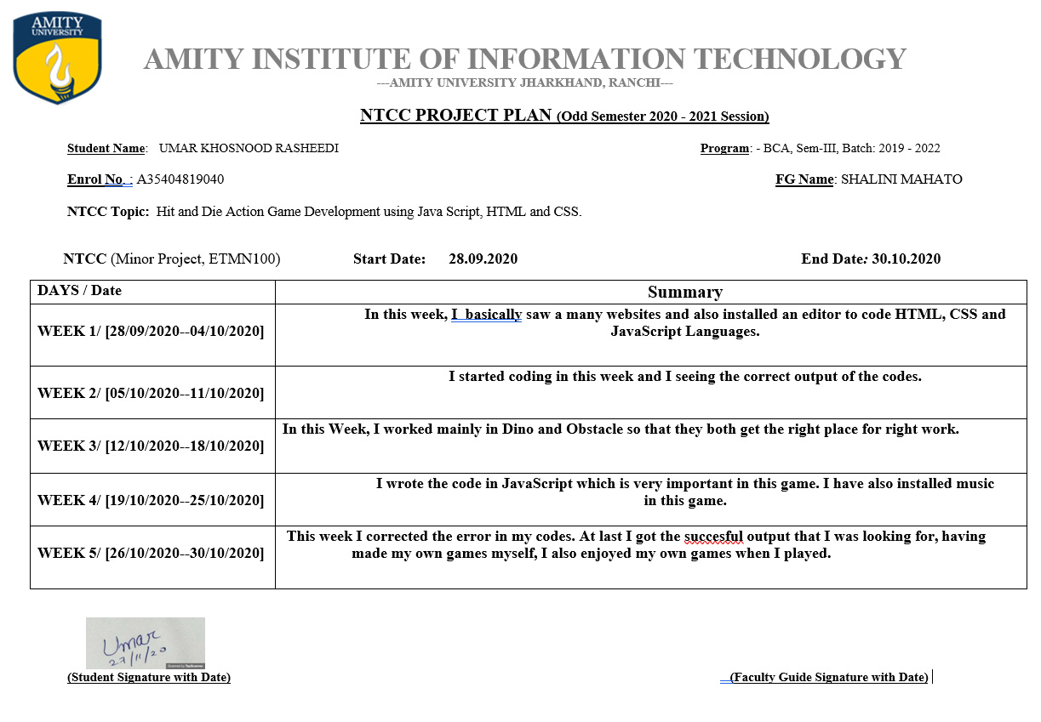

**WPR 🡪 1**

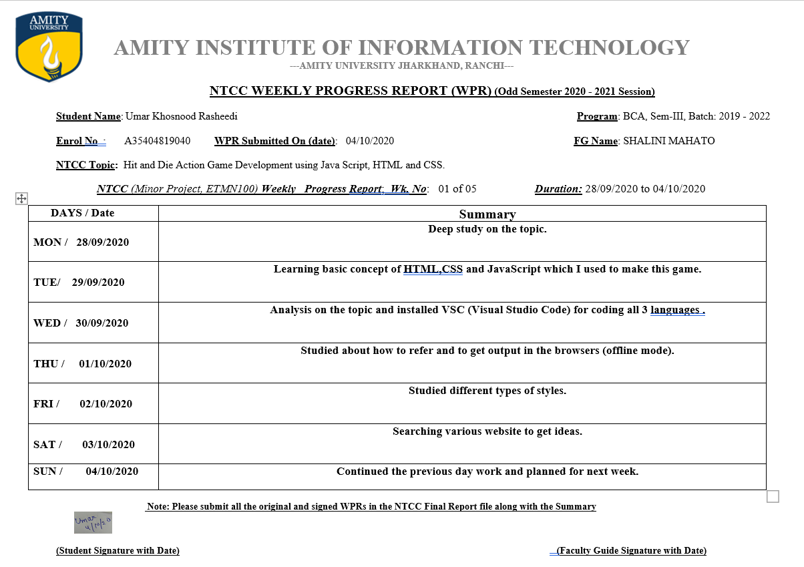

**WPR 🡪 2**

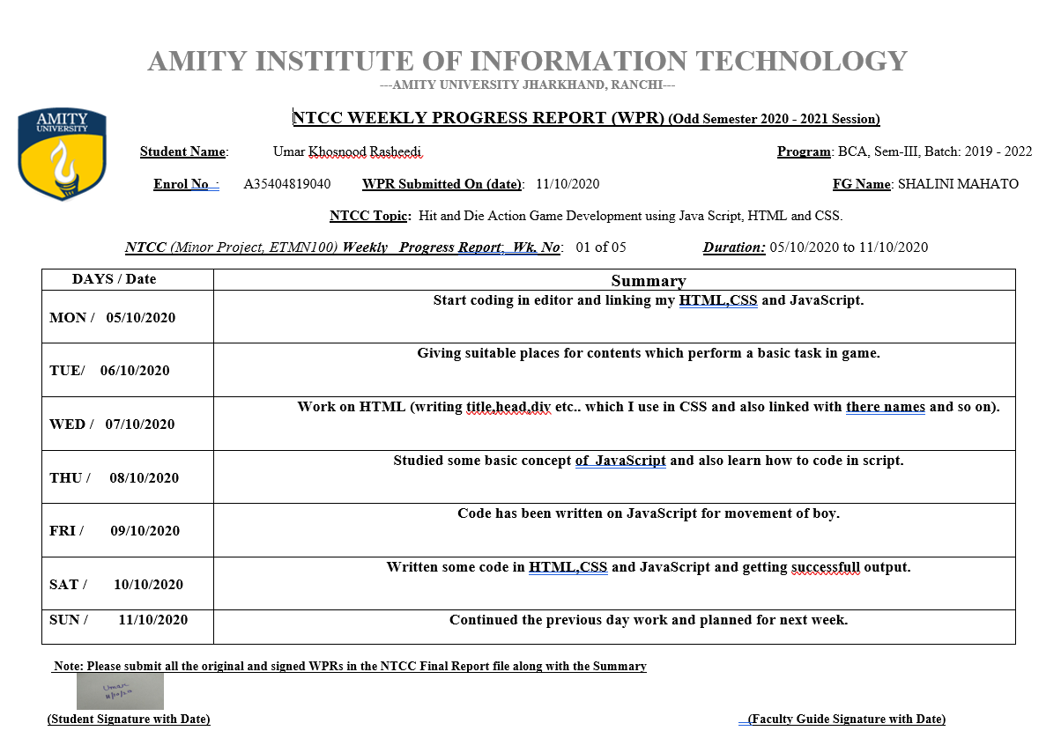

**WPR 🡪 3**

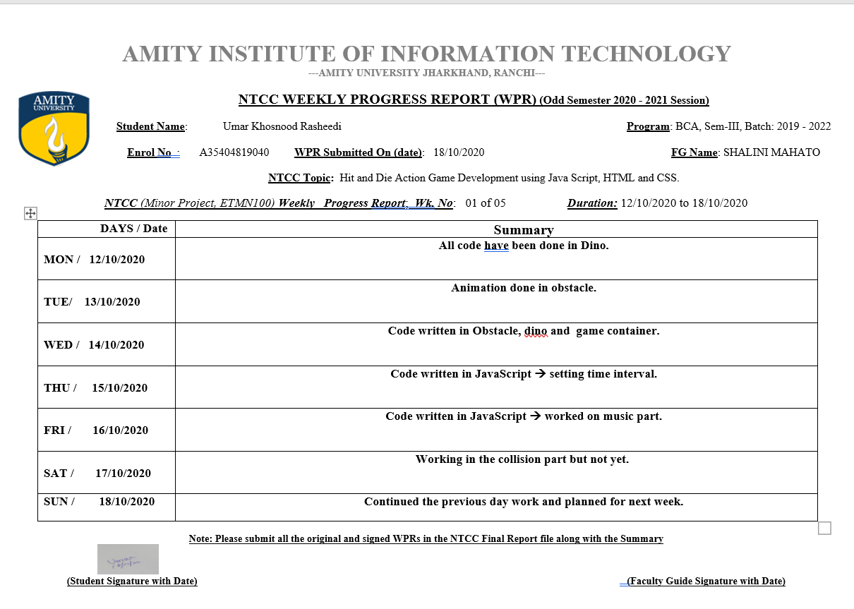

**WPR 🡪 4**

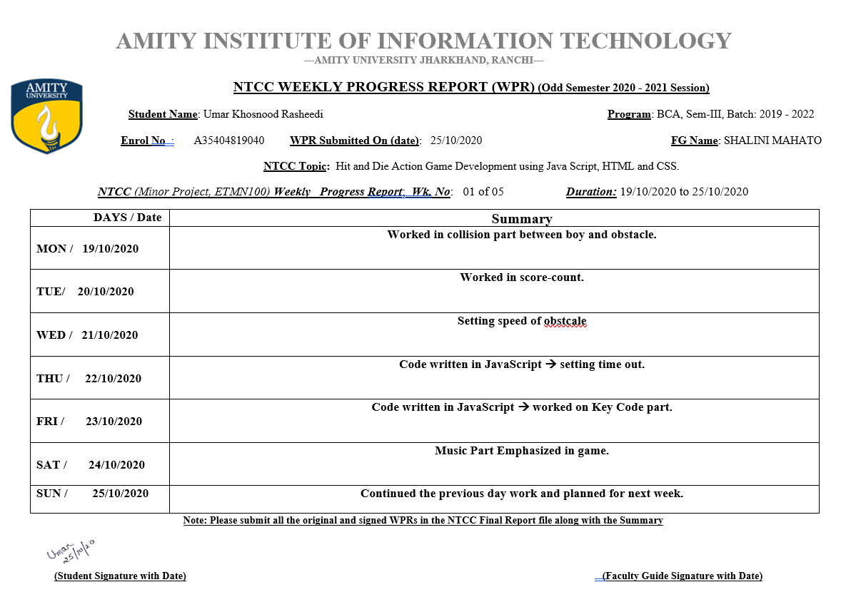

**WPR 🡪 5**

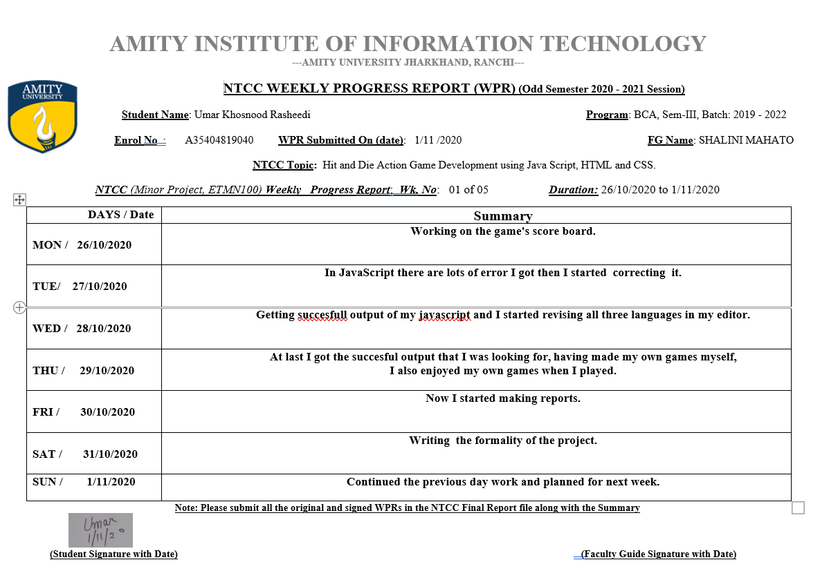

**Plagiarism Report**

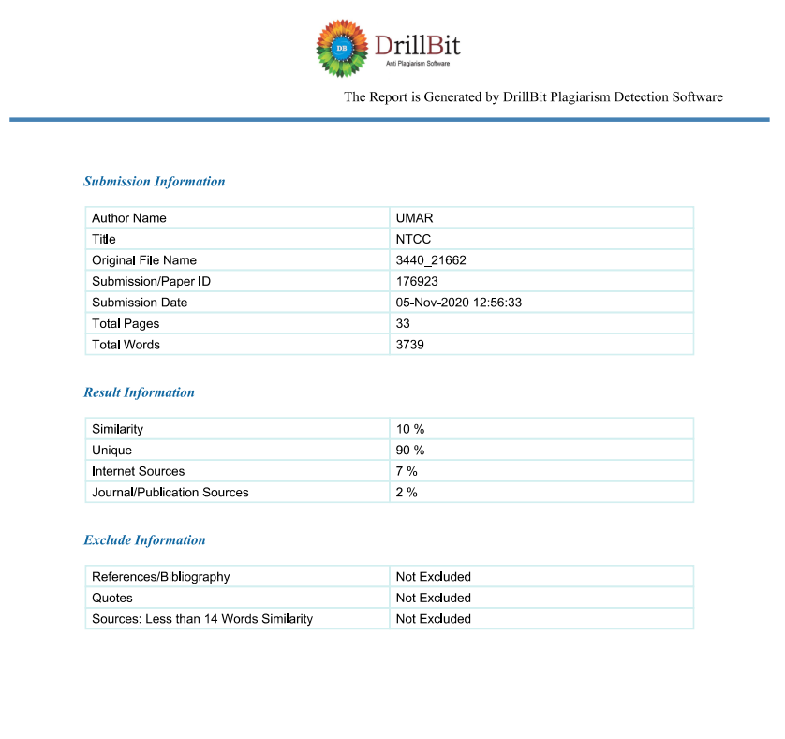

**TABLE OF CONTENTS**

|  |  |  |
| --- | --- | --- |
| **NO** | **CHAPTERS** | **PAGES** |
| ***1.*** | **Chapter-I -INTRODUCTION**   * ***Abstract.*** * ***Objectives & Scope of Project***. | ***08-09*** |
| ***2.*** | **Chapter-2 - SYSTEM IMPLEMENTATION DETAILS**   * ***Literature review.*** * ***Objective of the project.*** * ***Methodology.*** | ***10-14*** |
| ***3.*** | **Chapter -3 – SOURCES**   * ***Data Collection.*** | ***15-16*** |
| ***4.*** | **Chapter-4-ANALYSIS**   * ***Requirement analysis.*** * ***Problem analysis.*** | ***17-34*** |
| ***5.*** | **Chapter-5-RESULTS**   * ***Limitations.*** * ***Outcomes.*** | ***35-36*** |
| ***6.*** | **Chapter-6-SCOPES**   * ***Scopes of Study.*** * ***Scopes of Further Study.*** | ***37-38*** |
| ***7.*** | **Chapter-7-CONCLUSION** | ***39*** |
| ***8.*** | **Chapter-8-BIBLIOGRAPHY** | ***40*** |

**Abstract**

Hit and Die development game is a small program which is done by using using HTML, CSS and JavaScript and it is developed for fun and this is more for children, who keep their minds on a little bit. These programs have started from HTML language and finished in JavaScript. This program uses different features of HTML, CSS and JavaScript. I have developed this program using VS code (Visual Studio) editor. It also use graphics functions in the project. I have done hard work and a very hard labor to maintain the standard of the program. It is design to fulfill the user requirements and according to whatever you want will be found in the screen.

I have tried to show my best output of my program so that many people can attract and play this game.

I expect you to enjoy when you play this game.

**INTRODUCTION**

This is game mainly for kid who start learning the game how to play ,it is very simple and easy to understand . The main role in this game is dino,earlier I taken role of boy but it is not possible to adjust in this game that’s why I remove boy and take a dino and it is successful run in this game.

In this game I have taken 3 things which is useful first wallpaper,second dino and third is obstacle.

The important role in this game is how to jump dino in front of obstacle,moving of obstacle is continuously and we have to jump and if there is collision between dino and obstacle then there is end of game ,here we have to only save dino to collide.

I also include the scoring part in this if you jump, then the score will be increased or if you collide the obstacle , then the game will be over.

**LITERATURE REVIEW**

This game is made up of 3 languages.

* HTML
* CSS
* JavaScript.

**HTML** – HTML is stand for Hypertext Markup Language for documents designed to be displayed in a [web browser](https://en.wikipedia.org/wiki/Web_browser). It can be facilate by technologies such as [Cascading Style Sheets](https://en.wikipedia.org/wiki/Cascading_Style_Sheets)  and [scripting languages](https://en.wikipedia.org/wiki/Scripting_language) such as [JavaScript](https://en.wikipedia.org/wiki/JavaScript).

**CSS** – CSS stand for Cascading Styles Sheet it is that language which is used to style the Html sheet.it saves lot of work of html control the web pages at once. Html elements to be displayed on the screen. In this game I added many of the function which is useful for proper running the code like what is role of obsatacle, dino , score-cont , gameOver , animation and key frames.

**JavaScript -**It is very famous language in world and

it is very easy to learn. In this game I used this language because there is lots of function should be attach to work which I see in output part. Basically in this is work that I do is to make the movement of this game any way, whether it is to top any object or below or right left.

Here, I have done a function named Console which is used to define any variable and worked on 3 arrow bottoms, first the right arrow's second left arrow with the last front arrow key. I also set the time interval of dino and obstacle , dino is for jumping time interval when the obstacle will come in front of dino so this is done by parseInt and setting the offset part of this.

Here I also done the which is **If** and **Else** statement with time interval connected to score-cont.

**OBJECTIVE OF THE PROJECT**

In this project, basically a web-based game development where the main character is a dino who is standing at his place and the obstacle is continuously moving toward the character. To avoid the collision between the main character and the obstacle, the player (main character-the dino) must jump at the correct moment. In this this game there would be one default key( an arrow or an enter key). By pressing that key, the individual can safe the main character from collision with the obstacles by jumping across the obstacle. In this game the obstacle will be a Dinosaur and the main character is dino. In each successful jump the score will increase by 1. This game increases the level concentration of an individual. The concepts used for the development of the game are HTML, CSS(Cascading Style Sheet) and Javascript

**METHODOLOGY**



🡪Planning



🡪 Conducting



🡪Presenting

**DATA COLLECTION**

I have collected different data from different resources which was needed for making my game.

The data that has been collected by me is :-

1. Images
2. Sounds
3. Google Fonts
4. Colors

**IMAGES :-**

I have collected different types of different of images of different images like jpg as well as png type. The different images that I have collected are :-

1. Background(wallpaper).
2. Dino
3. Obstacle

**SOUNDS :-**

I have collected different types of sounds from different resources. All the sounds are of mp3 format. In total I have collected two different sounds for game which are :-

1. Starting sound for the game.
2. When there will be a collision of dino and obstacle.

**Google Fonts :-**

I have collected different types of fonts from different resources. There are many fonts which I used in this game Looking through the entire website, I have put a font in it.

**Colors :-**

I have collected different types of colors from different resources. I have seen all the colors in many games, so I have taken all the ideas from that and applied to it.

**ANALYSIS**

**Requirement Analysis** –

To make this game, I need a 3 png file and 2 mp3 music.

**#** First I tried to find the best wallpapers in the net, I found a wallpaper which is an inexplicable wallpaper that looks very exciting.

1.Wallpaper.

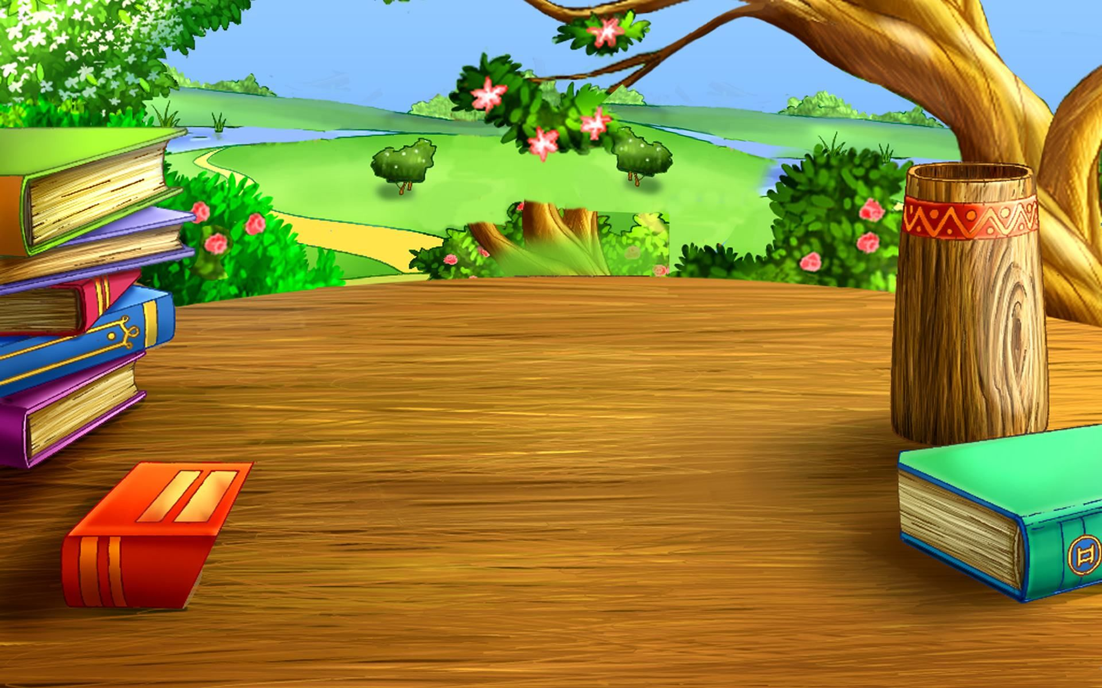

*(Wall.png)*

**#** Secondly I took a dino png file but this game could not fit successfully, so after changing it , I gave dino which was succesfull run.

2. dino

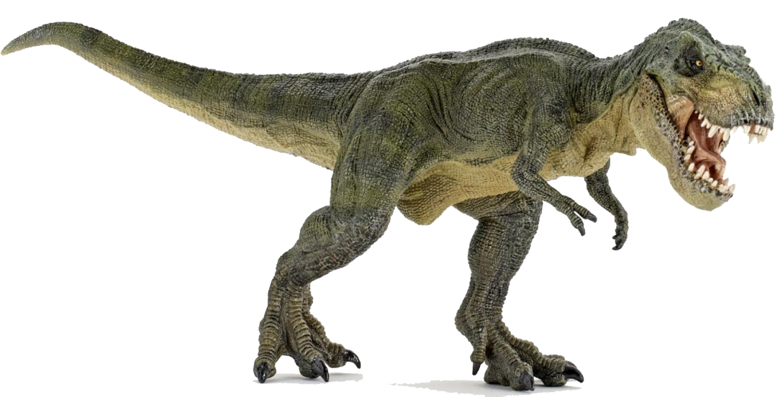

**#** The third one is obstacle which is running from bottom corner to right corner.

3. obstacle

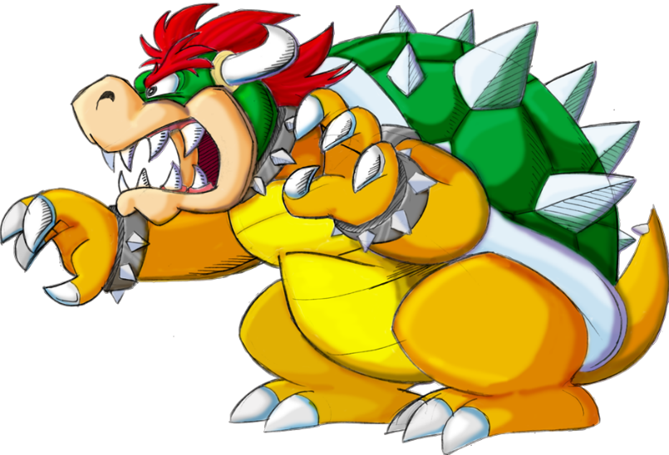

In this game, I also had added 2 music, one music will play when the game is running and another one when the game is over.

When the game is running :-



When the game is over :- 

It is the only thing that we needed to make this game, the things that will have to be done in the editor under the languages of Html, Css and JavaScript.

**Problem analysis**

Use of Html in this project is to link the folder of css and javascript ,also include section of class and div which is very useful role in project.Link of css and javascript is very important because without link there is no use of css and javascript here. If we don’t link then there is no use of css and javascript and we only saw the output of Html.without using of css and javascript I can’t make this game.

For example I have to add something in the part of css and did not add in Html then there is totally useless of that part with I used in css.

I used the tag of div in body part for showing gameover in which I taken style for font cursive, color is darkblue and also increase the size of font with 78px. Then after that I written Welcome to iDragon Adventures. (Created by Umar ).

<div class="gameOver" style="font-family:cursive; color:darkblue; font-size: 78px;" ><b>Welcome to iDragon Adventures </b><br>Created by Umar.  </div>

**Output :-**

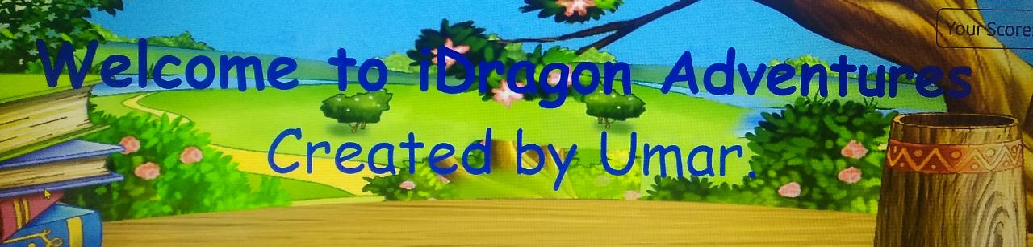

After thatI include dinoo, obstacle and score-Cont in same body of html for run the code.

 <div class="dinoo"></div>

        <div id="scoreCont">Your Score: 0</div>

        <div class="obstacle obstacleAni"></div>

Use of CSS in this game firtly I

want to see my dino and obstacle on my web page that is why I worked first in this. So the my first task is to set the background and see the ineffectiveness in web page ,then dino- in the part of dino under carly bracket I had taken background image, background repeat, width, height, position, bottom, left.

**For dino**

Uses:-

Background-image:- It is a set of property of background image

for an element. (dinoo.png).

Background-repeat :- It means whether a element moving

Vertically or Horizontal (In this game I set

Horizontally and it is no-repeat).

Background-size :- It specifies the size of element (Here the size

of element is cover because it cover entire

container and stretch the element).

Width :- It sets the width of an element(Here the width

is 233px).

Height :- It sets the height of an element(Here the height

is 144px.

Position :- It method used for an element (static,

Relative, fixed, sticky or absolute).[Here the

Position is absolute).

Bottom :- It tottaly affect the vertical position so that is

(here the value of bottom is 0).

Left :- It is used for horizonatl position for whether

we have to place the element

Code for dino is :-

.dinoo{

    background-image: url(dinoo.png);

    background-repeat: no-repeat;

    background-size: cover;

    width: 233px;

    height: 114px;

    position: absolute;

    bottom:0;

    left: 52px;

}

Output :-

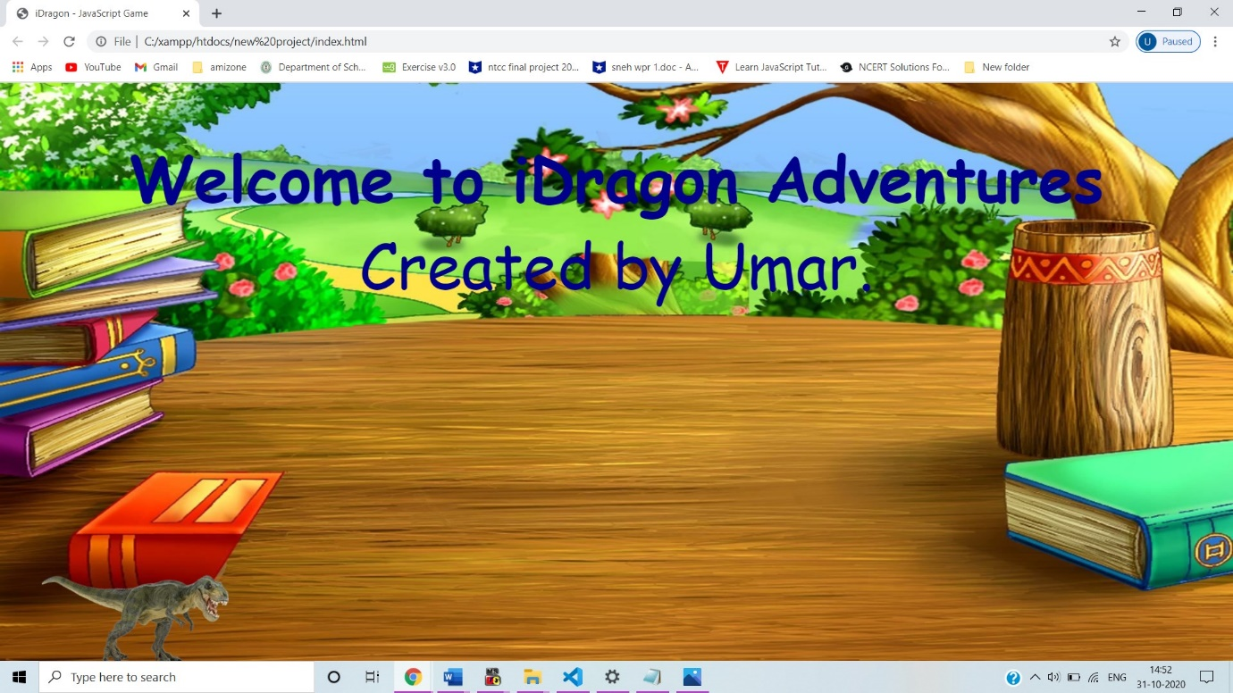

**Obstacle**

Uses:-

Background-image:- It is a set of property of background image

for an element. (obstacle.png).

Background-repeat :- It means whether a element moving

Vertically or Horizontal (In this game I set

Horizontally and it is no-repeat).

Background-size :- It specifies the size of element (Here the size

of element is cover because it cover entire

container and stretch the element).

Width :- It sets the width of an element(Here the width

is 166px).

Height :- It sets the height of an element(Here the height

is 113px.

Position :- It method used for an element (static,

Relative, fixed, sticky or absolute).[Here the

Position is absolute).

Bottom :- It tottaly affect the vertical position so that is

(here the value of bottom is 0).

Left :- It is used for horizonat position for whether

we have to place the element (left:44vw).

Code for obstacle is :-

.obstacle{

    width: 166px;

    height: 113px;

    background-image: url(dragon.png);

    background-size: cover;

    position: absolute;

    bottom: 0;

    left: 44vw;

}

Output:- 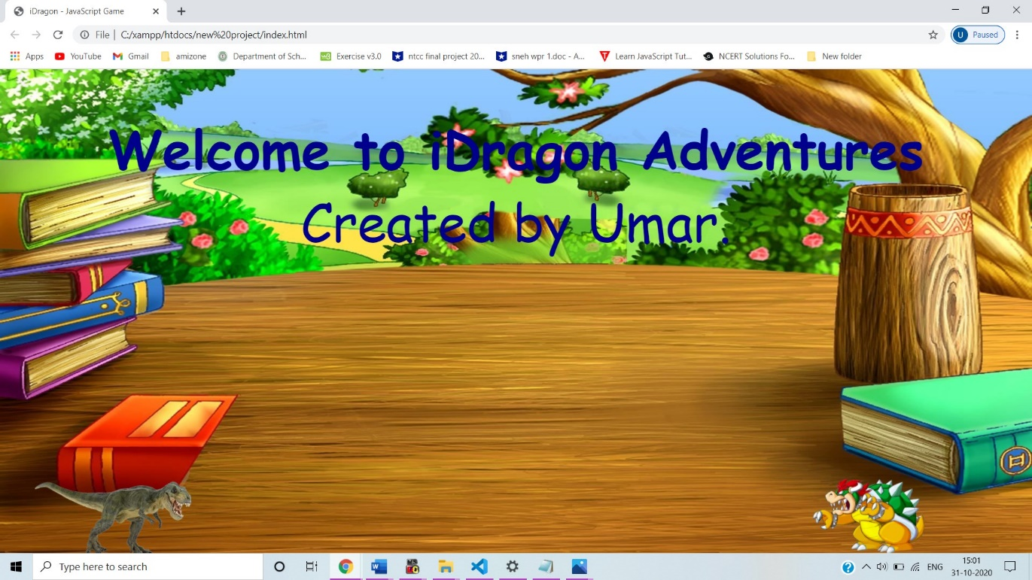

**@keyframes**

Use:-

The main use of keyframes is to animation of object is to move one place to another or we can also say that the element will move from place to another. Here we see two thing first is 0% and the other 100%.

The meaning of 0% is beginning of animation & 100% means is complete of animation.

Here I had done animation of 2 things because I had to move dino as well as obstacle so the code will be different for both because the work of dino is to avoiding obstacle simultaneously moving of obsctale is continuously.

Animation for dino is :-

@keyframes dino{

    0%{

        bottom: 0;

    }

    50%{

        bottom: 422px;

    }

    100%{

        bottom: 0;

    }

Output:-

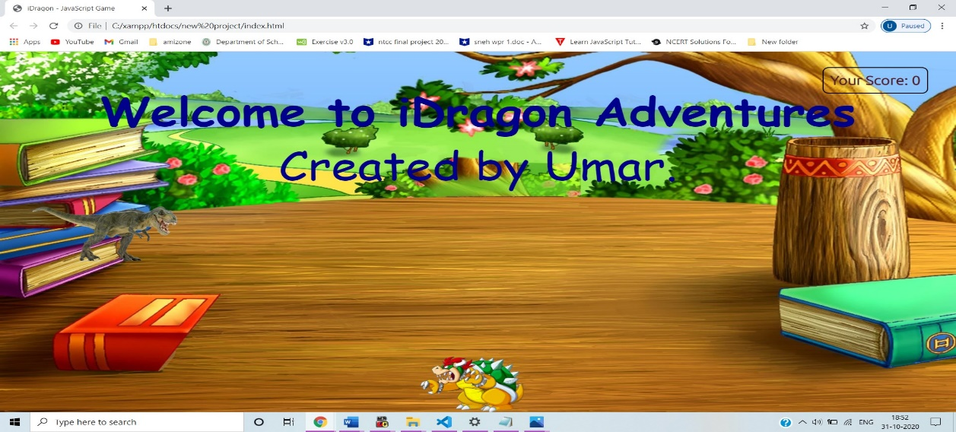

Animation of obstacle is:-

@keyframes obstacleAni{

    0%{

        left: 100vw;

    }

    100%{

        left: -10vw;

    }

}

Output

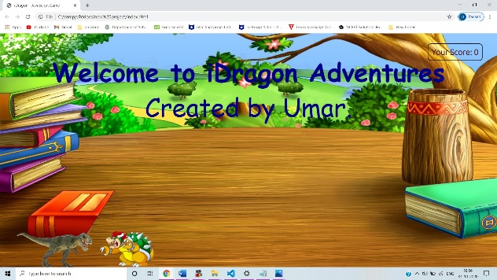 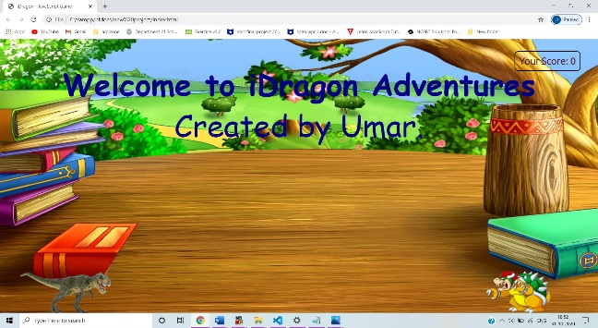

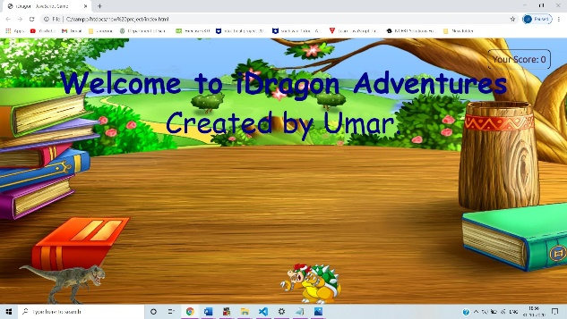 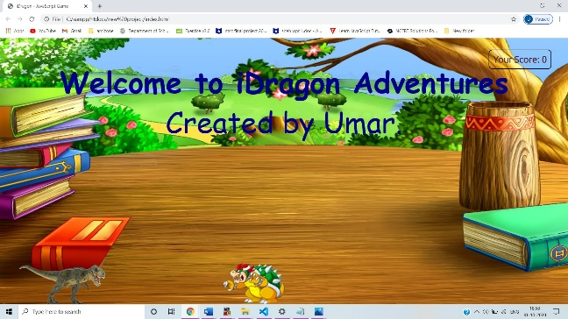

**Score-cont**

There are many ways to count the score in game but I use very simple and easy method to understand for who is seeing my code.

First of I started with size of font ,then chosen color of font then position of score-board which I fixed right side top corner because I saw many of the games score-board had been kept in right side of top corner that is why I put there only. I also set the border of score-board with black color.

Code of score-cont is :-

#scoreCont{

    font-size: 25px;

    color: #54212f;

    font-weight: bold;

    position: absolute;

    right: 45px;

    top: 31px;

    border: 2px solid black;

    padding: 10px;

    font-family: 'Ubuntu', sans-serif;

    border-radius: 10px;

}

Output:-

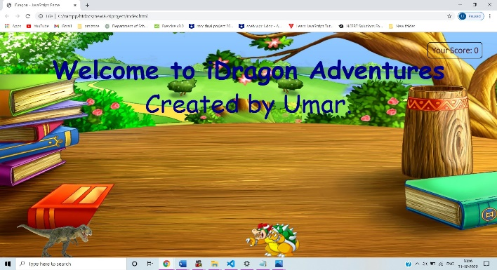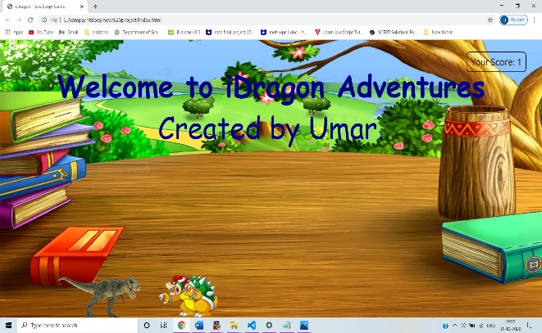

**Scores are 0 to 1.**

**Game Over**

Whenever dino and obstacle these two collide, then the game will be over and also we can see in the screen that the Game Over-reload to play again. This line look at the top of the line screen so that it is highlighted.

Code for gameover :-

.gameOver{

    position: relative;

    top:63px;

    font-size: 53px;

    text-align: center;

    font-family: 'Ubuntu', sans-serif;

}

Output :-

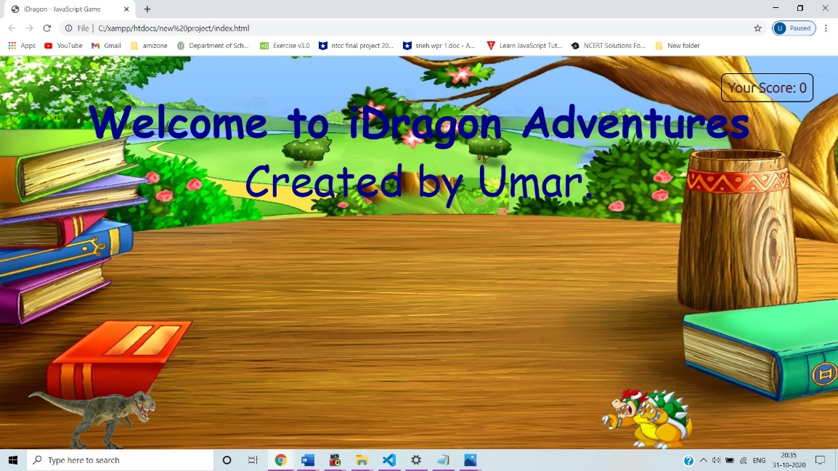

(At the time of playing)

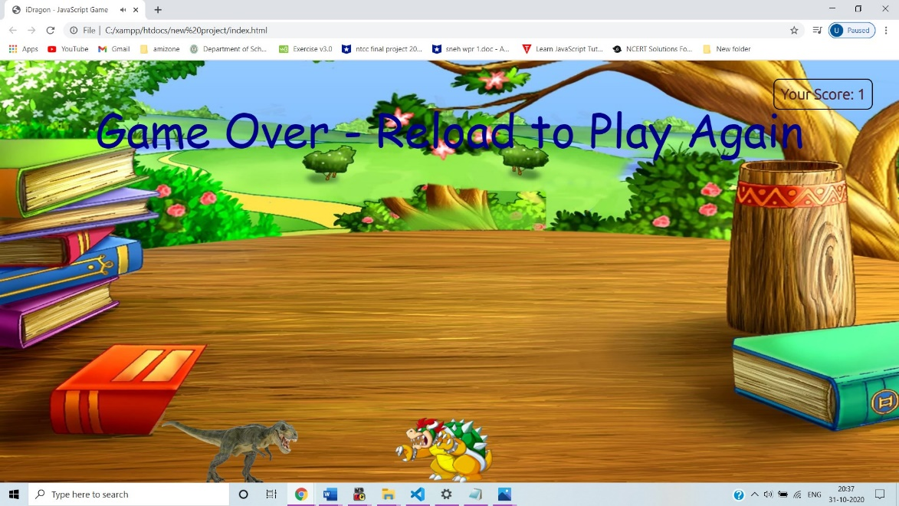

(At the time of game over ).

Use of javaScript in this to set the time interval of dino as well as obstacle Here, a function named Console which is used to define any variable and worked on 3 arrow bottoms, first the right arrow's second left arrow with the last front arrow key. I also set the time interval of dino and obstacle , dino is for jumping time interval when the obstacle will come in front of dino so this is done by parseInt and setting the offset part of this.

To make a game, it is important for us to know the what is a keycode for all the bottom present in keyboard.

Lets, first tell you that the right arrow keycode is 39. And the code for this game according to this key is :-

if (e.keyCode == 39) {

        dino = document.querySelector('.dinoo');

        dinoX = parseInt(window.getComputedStyle(dino, null).getPropertyValue('left'));

        dino.style.left = dinoX + 112 + "px";

    }

Keycode for left arrow key is 37. And the code for this game is :-

 if (e.keyCode == 37) {

        dino = document.querySelector('.dinoo');

        dinoX = parseInt(window.getComputedStyle(dino, null).getPropertyValue('left'));

        dino.style.left = (dinoX - 112) + "px";

    }

}

Keycode for up arrow key is 38. And the code for this game is :-

if (e.keyCode == 38) {

        dino = document.querySelector('.dinoo');

        dino.classList.add('animateDino');

        setTimeout(() => {

            dino.classList.remove('animateDino')

        }, 700);

    }

**Time Interval**

In this, I have also given the setting of time interval for dino and obstacale. Here the definition of time interval is to call the funaction which is specified (in milli-secound) and it is continuously calling the function.

Here the 1000ms=1secound.

Also used parseInt() function it is string and returns the integer.

* If the string begins with "0x", the radix is 16 (hexadecimal)
* If the string begins with "0", the radix is 8 (octal). This feature is deprecated
* If the string begins with any other value, the radix is 10 (decimal).

Code for time interval:-

setInterval(() => {

    dinoo = document.querySelector('.dinoo');

    gameOver = document.querySelector('.gameOver');

    obstacle = document.querySelector('.obstacle');

    dx = parseInt(window.getComputedStyle(dino, null).getPropertyValue('left'));

    dy = parseInt(window.getComputedStyle(dino, null).getPropertyValue('top'));

    ox = parseInt(window.getComputedStyle(obstacle, null).getPropertyValue('left'));

    oy = parseInt(window.getComputedStyle(obstacle, null).getPropertyValue('top'));

After used the time interval I prefer to use should set the music while the game is running and when the game is over.

Code for audio :-

audio = new Audio('music.mp3');

audiogo = new Audio('gameover.mp3');

**If and Else**

After that I started doing **if** and **else** statement work was done in game. We know that the meaning of **if** is which consists true part only and **else** means to consists false part. But here I thought that if dino jump infront of obstacle then score will increase by 1, this part should be done under **if** statement and if there is a collision between dino and obstacle then game should be over and this work under **else** statement.

I also added one more function ,when the game is over, it will show automatically on the screen , Game Over – Reload to play again. I did a one function to do this and the name of the function is gameoOver.innerHTML.

Code for if and else statement is :-

if (offsetX < 73 && offsetY < 52) {

        gameOver.innerHTML = "Game Over - Reload to Play Again"

        obstacle.classList.remove('obstacleAni')

        audiogo.play();

        setTimeout(() => {

            audiogo.pause();

            audio.pause();

        }, 1000);

    }

    else if (offsetX < 145 && cross) {

        score += 1;

        updateScore(score);

        cross = false;

        setTimeout(() => {

            cross = true;

        }, 1000);

**Update Score**

I had defined a function here which will keep the score updated. To use it, a function is required which is updateScore.

The main task is here is that the game score should continue to be incraesed when dino jump in front of obstacle and when the game is over, the increment of score should stop.

Code for update score :-

function updateScore(score) {

    scoreCont.innerHTML = "Your Score: " + score

}

**Advantages Of Game**

Here the main thing is if dino is continuously jump infront of coming obstacle then score will be increased by 1 and its continuous going on.

**Disadvanatges Of Game**

If dino bump into obstacle then score will be not going to increased and its shows the game is over reload to play again.

**OUTCOMES / RESULTS**

My result which will be in this game is that the code I have written in three languages which is HTML, CSS and JavaScript is successfully run. I had a lot of problems in writing the code, especially in JavaScript, I was very disturbed but I got successful at the last movement.

At last I got the successful output that I was looking for, having made my own games myself, I also enjoyed my own games when I played.

When we go to see the output, we will get a game started with a music. In which the coming of the right side obstacle will be continously. At one place the dino should be paused, it work when we want . When I press the up arrow the dino will be jump , and when press the left arrow then the dino will go left side at the same if we press right arrow the dino will go right. By doing this, we can save our dino from the obstacle.When the dino jump from the front of the obstacle, then the score will also be increased, which we can see this score in our screen as well. This score will continue to be increased, unless when the dino and the obstacle will not be bumped.

When it collides, the game will be over and it will be written in the screen that the Game Over – Reload to play again.

***This will be the end of my game and this will be the output of my successful coding which I coded.***

**SCOPE OF STUDY**

First of all, my main scope to make this game so that my knowledge has become incremented. Everyone wants big thing and often imagine making a game at the quality level. For now let’s just figure out what we can actually accomplish. I have used 3 types of languages ​​in this game:-HTML,CSS and JavaScript.

In my face, there was a kind of knowledge of Html, which I never knew before. What kind of tag is there to know when to apply this , I don’t had a lot of knowledge but I have received a lot of knowledge in this game.

I don’t had knowledge of CSS and JavaScript because I had not studied this languages ​​before, but still I got a lot of knowledge how to use it , how to adjust the code from one place to another ,how to connect one tag to some other tag. I am grateful to my college that I got a chance to do this work. With which I got to learn a lot of things regarding making games in future I want to explore this game through my future work. So that I can make this game from scratch too.

**SCOPE FOR FURTHER STUDY**

This game that I have made, I will not stop at this, I will take this game forward so that I can learn more knowledge. With this game, I am getting a lot of knowledge, which is getting exactly match with the scope of my life.

All this thing is going to work in front of me, even if it is going to be useful, so I will continue this way so that I can get knowledge. All this thing is very important for my upcoming life, that’s why I should read this thing in a good way.

**Research Methodology**

**DFD ( Data Flow Diagram)**

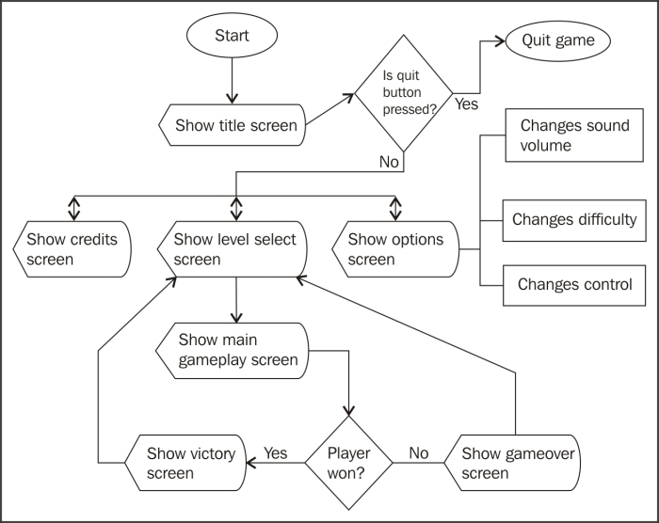

**CONCLUSION**

The summery internship projects play an important role for the students where they get a golden opportunity to apply his knowledge and learning gained from the classroom knowledge.

It helps the student a lot in gaining knowledge and developing the confidence level it.

The project i.e the ***Hit and Die game development*** using HTML, CSS, JavaScript help me a lot in order to explore my knowledge in this three languages. I came to know many thing about languages and its practical use in developing website or game.

By doing this project I have increased my game developing skills using HTML, CSS and JavaScript and to have good practical knowledge in the programmimg world. It made my coding skills more stronger.

**BIBLIOGRAPHY**

To make this project I have taken source from the following website :-

1. <https://www.w3schools.com/html/default.asp> (for HTML).

2. <https://www.w3schools.com/css/default.asp> (for CSS).

3.<https://www.w3schools.com/js/default.asp> (for JavaScript).

4. <https://www.javatpoint.com/javascript-tutorial> ( for JavaScript).

I also taken many png file from different types of different resources.